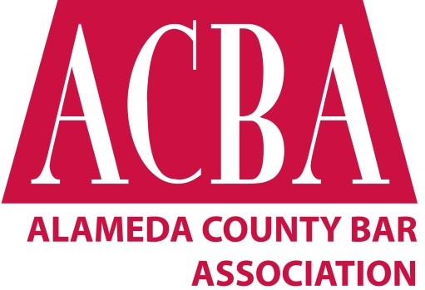
Volunteer Removal Policy
Adopted November 9, 2021

If a member of the Board of Directors, Section Executive Committee, or Committee, or a Member of the Association, is the subject of an effort to remove that person from that role as specified and permitted in the most current Association Bylaws, the following procedures shall be followed:
- The person shall be provided with advance written notice of the proposed removal, including the reason for the proposed removal. Said notice shall be provided at least two weeks prior to any final decision by the deciding entity, in the absence of emergency. An emergency situation must be determined to be so by unanimous agreement of the three Association Officers. The notice shall also specify the time, date, and location of the meeting at which the decision will be made. The notice will be sent by email.

- The written notice shall offer the person the opportunity to respond in writing to the deciding entity. The person must submit said writing at least 3 business days prior to the meeting date specified in the notice described in Paragraph 1, above. The writing should be submitted to the President, the Chair of the Committee or Section, or the ACBA CEO by email. Writings should not exceed 5 pages, double-spaced, total.

- The person shall also be offered the opportunity to address the meeting at which the decision will be made. A person who wishes to accept this opportunity must notify the President, the Chair of the Committee or Section, or the ACBA CEO at least 3 business days prior to the meeting of their desire to address the meeting. The person will be given a maximum of 10 minutes in which to address the meeting, after which the person will be excused from the meeting, while the meeting proceeds in closed session.

- Following the meeting, the person will be provided with written notification of the final decision made at the meeting.

