COUNTY OF SAN JOAQUIN CIVIL DEPARTMENT QUICK REFERENCE INFORMATION DURING OFFICE CLOSURE
FILING DOCUMENTS:
- If not an excluded filing, submit via eFiling at https://appfile.sjcourts.org/
- Submit via mail
- Submit via drop box between 8 AM and 4 PM. Boxes are available at Stockton, Manteca and JJC.
- Include a self-addressed stamped envelope for conformed copies to be returned by mail. Otherwise, the copies will be placed in the attorney, firm or courier’s pick up folder located at the Information Desk.
NOTE: THE WINDOWS LOCATED ON THE FIRST FLOOR OF THE STOCKTON COURTHOUSE ARE AVAILABLE FROM 8-10 AND 3:30-5 AND ONLY AVAILABLE FOR DROPPING OFF OR PICKING UP CIVIL, DOMESTIC VIOLENCE AND ELDER ABUSE RESTRAINING ORDERS. NO OTHER DOCUMENTS ARE ACCEPTED UNLESS BY JUDICIAL ORDER. A COVERSHEET OR COPY OF THE MINUTE ORDER CONTAING THE COURT’S ORDER THAT THE DOCUMENT BE TAKEN AT THE WINDOW MUST BE ATTACHED.
COURTESY COPIES:
- If courtesy copies have been ordered, please label them “Courtesy Copy” and place them in the Civil drop box located outside of the Stockton Courthouse. Please submit them timely to allow a day or 2 for delivery to the judicial officer.
CONTACTING THE COURT:
- Clerks office related inquiries can be submitted via the support link on the Court’s website at https://www.sjcourts.org/online-services/support/. Select Civil and Restraining Orders from the drop down menu in order to reach the Civil department’s staff. Other departments can be contacted in the same manner.

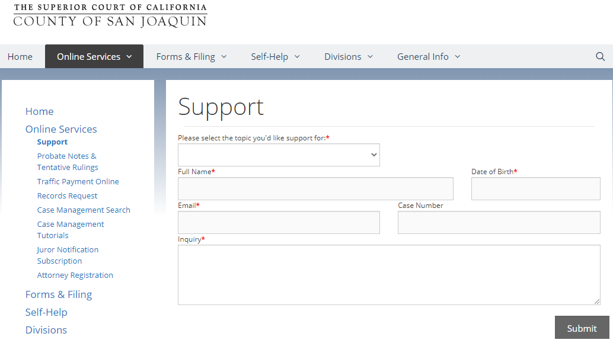

- The courtroom clerks are not available by phone. To contact the Civil courtroom clerks for department specific related inquiries, for approval to schedule an ex parte or notify the court of your intention of contesting a tentative ruling, email civilcourtclerks@sjcourts.org. Include the department number and judge’s name in the Subject Line.
REGISTRATION FOR TEXT/EMAIL NOTIFICATIONS:
- If you would like to receive text and/or email notifications and reminders for upcoming hearing dates, please register at https://www.sjcourts.org/online-services/attorney-registration/
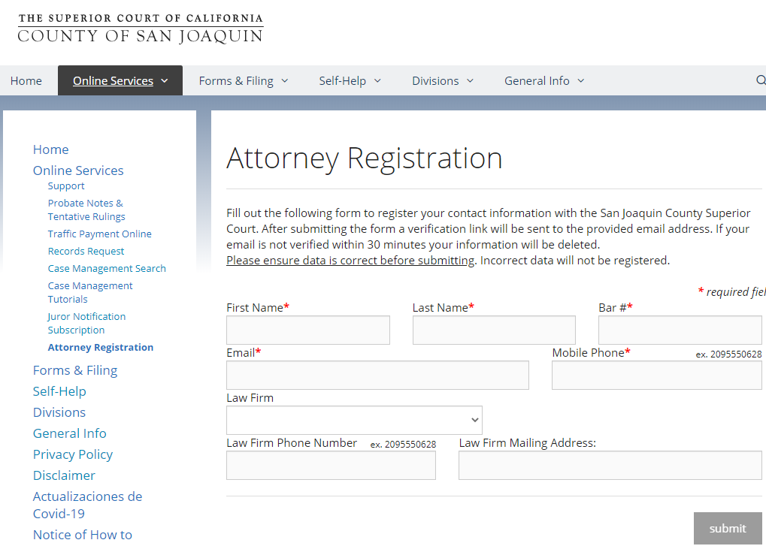

UPDATES:
- Please continue to monitor the court’s website at https://www.sjcourts.org/ for updates regarding operations as things are subject to change.

We thank you for your continued patience during this time.

6.23.2020

